**SQL Statement as a Source**

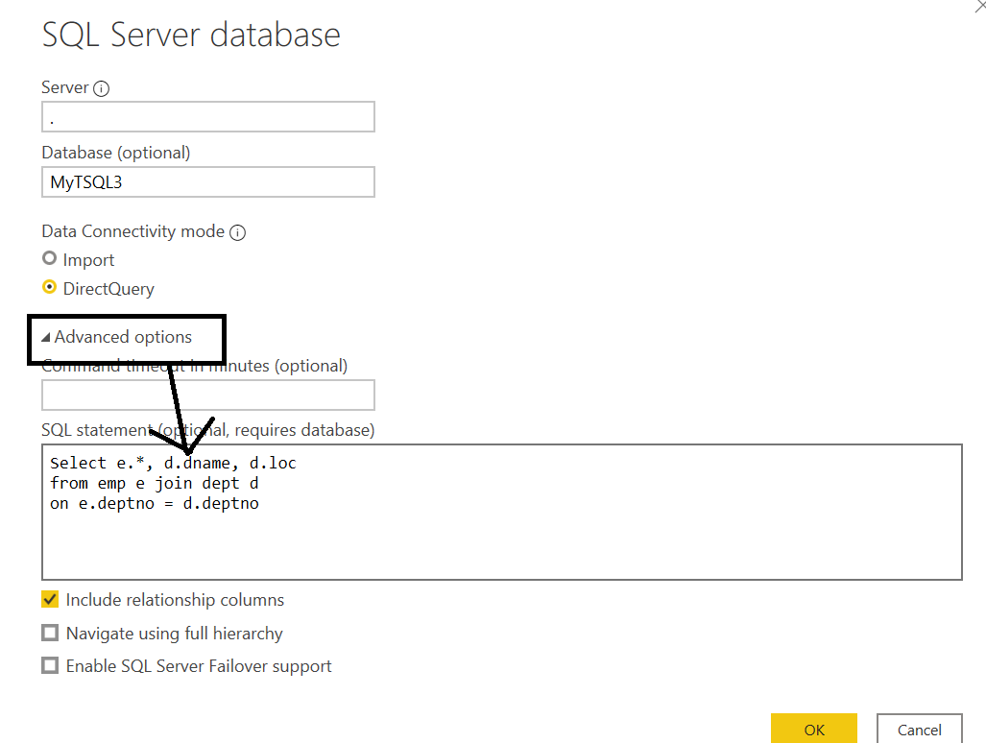

The select statement is:

Select e.*, d.dname, d.loc

from emp e join dept d

on e.deptno = d.deptno

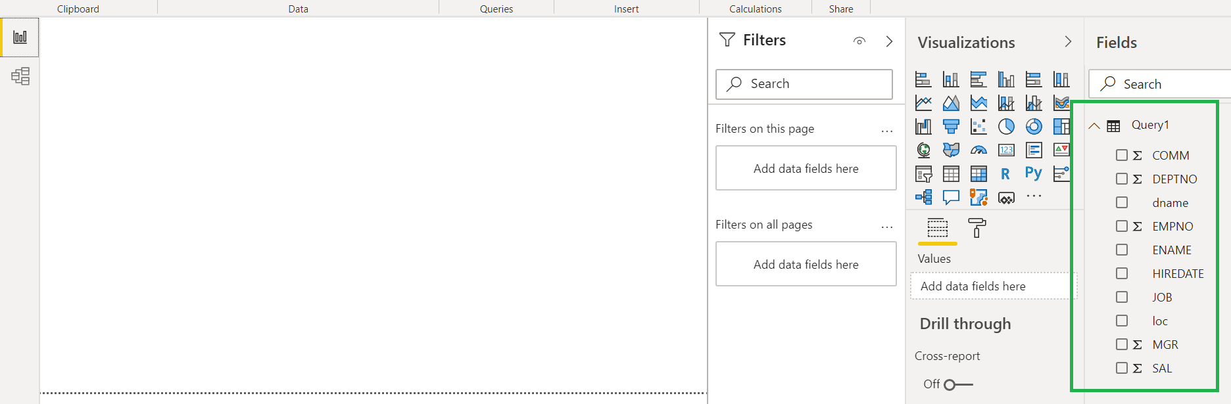

The table gets by default name as **Query1**, which you should ideally later rename.